SQL Lesson 1: SELECT queries 101

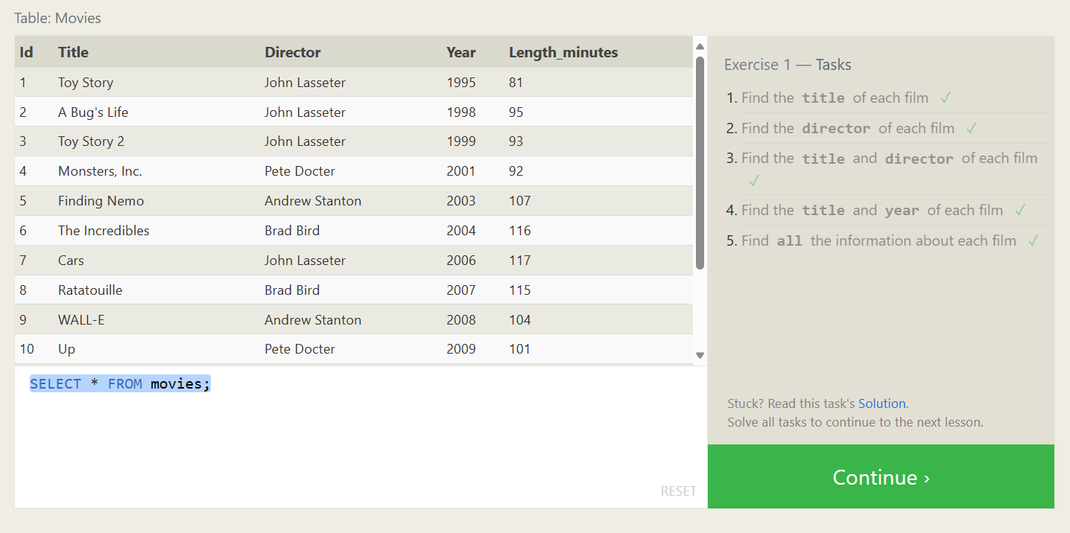

SELECT title FROM movies;

SELECT director FROM movies;

SELECT title, director FROM movies;

SELECT title, year FROM movies;

SELECT * FROM movies;

SQL Lesson 2: Queries with constraints (Pt. 1)

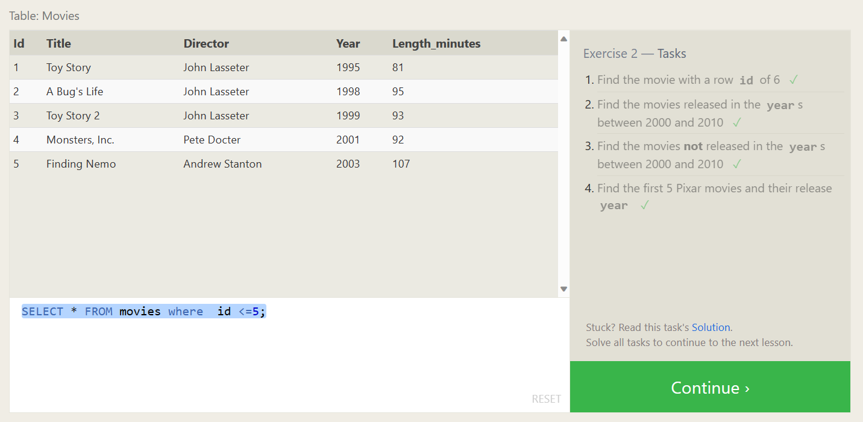

SELECT * FROM movies where id =6;

SELECT * FROM movies where year between 2000 and 2010;

SELECT * FROM movies where year not between 2000 and 2010;

SELECT * FROM movies where id <=5;

SQL Lesson 3: Queries with constraints (Pt. 2)

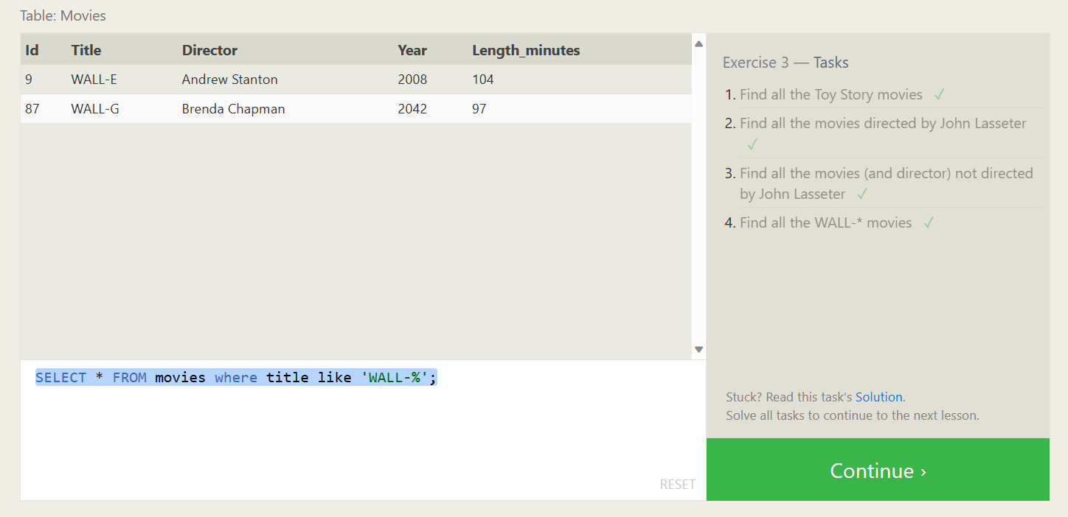

SELECT * FROM movies where title like 'Toy story%';

SELECT * FROM movies where director =' John Lasseter';

SELECT * FROM movies where director != 'John Lasseter';

SELECT * FROM movies where title like 'WALL-%';

**SQL Lesson 4: Filtering and sorting Query results**

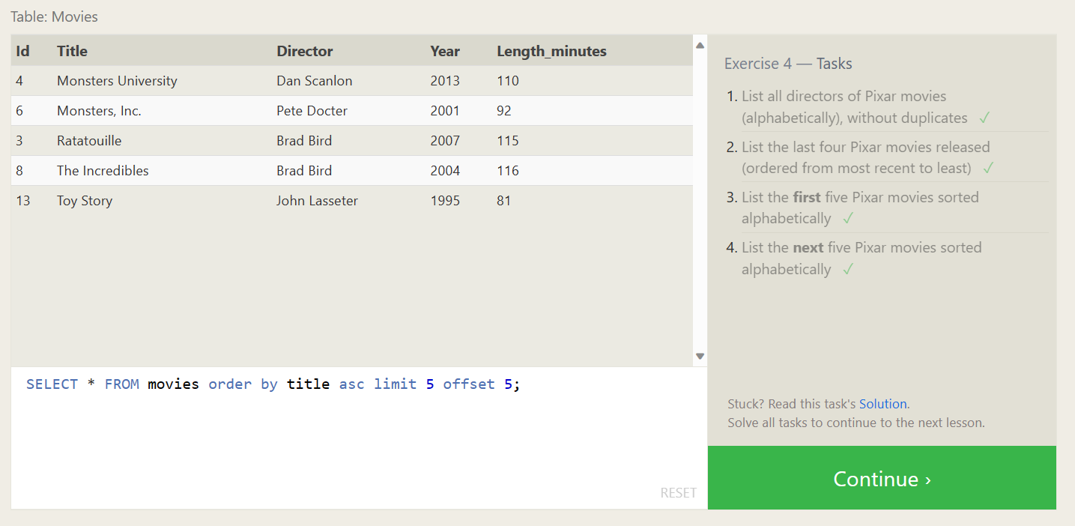

SELECT distinct director FROM movies order by director;

SELECT * FROM movies order by year desc limit 4;

SELECT * FROM movies order by title asc limit 5;

SELECT * FROM movies order by title asc limit 5 offset 5;

**SQL Review: Simple SELECT Queries**

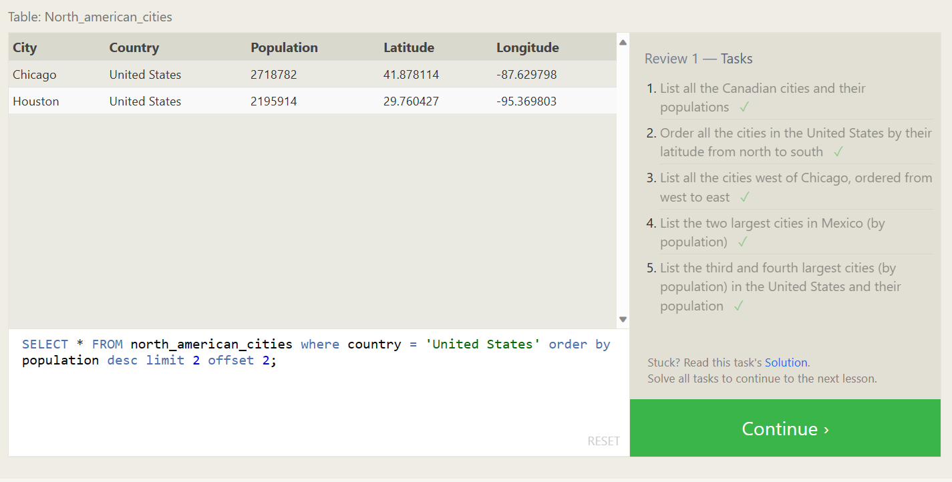

SELECT * FROM north_american_cities where country = 'Canada';

SELECT * FROM north_american_cities where country = 'United States' order by latitude desc;

SELECT * FROM north_american_cities where longitude < -87.629798 order by longitude asc;

SELECT * FROM north_american_cities where country = 'Mexico' order by population desc limit 2;

SELECT * FROM north_american_cities where country = 'United States' order by population desc limit 2 offset 2;

**SQL Lesson 6: Multi-table queries with JOINs**

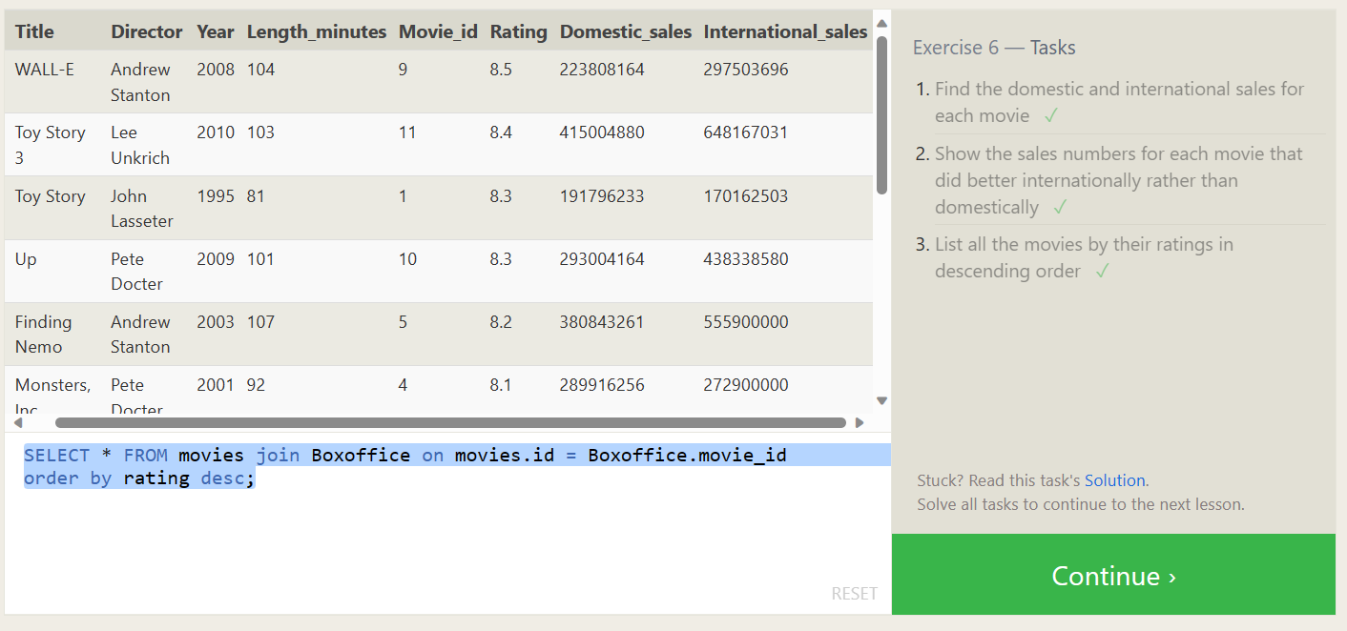

SELECT * FROM movies join Boxoffice on movies.id=Boxoffice.movie_id;

SELECT * FROM movies join Boxoffice on movies.id = Boxoffice.movie_id where International_sales > Domestic_sales;

SELECT * FROM movies join Boxoffice on movies.id = Boxoffice.movie_id

order by rating desc;

**SQL Lesson 7: OUTER JOINs**

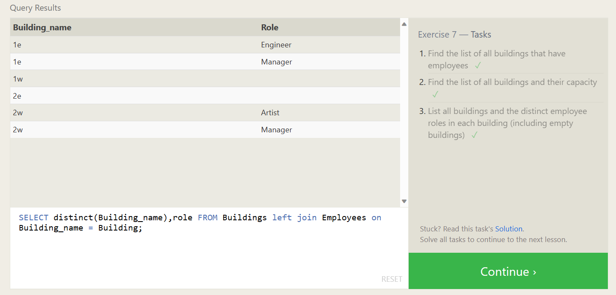

SELECT distinct(Building) FROM employees;

SELECT * FROM Buildings;

SELECT distinct(Building_name),role FROM Buildings left join Employees on

Building_name = Building;

**SQL Lesson 8: A short note on NULLs**

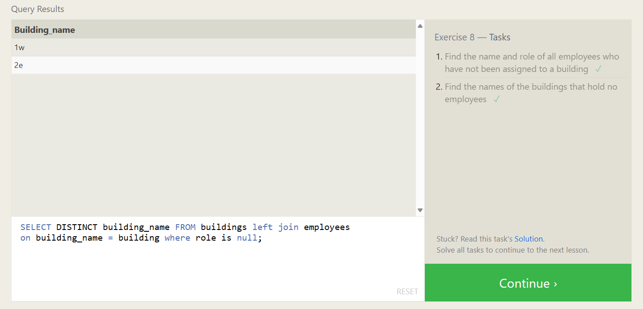

SELECT name, role FROM employees where building is null;

SELECT distinct building_name FROM buildings left join employee on building_name = building where role is null;

**SQL Lesson 9: Queries with expressions**

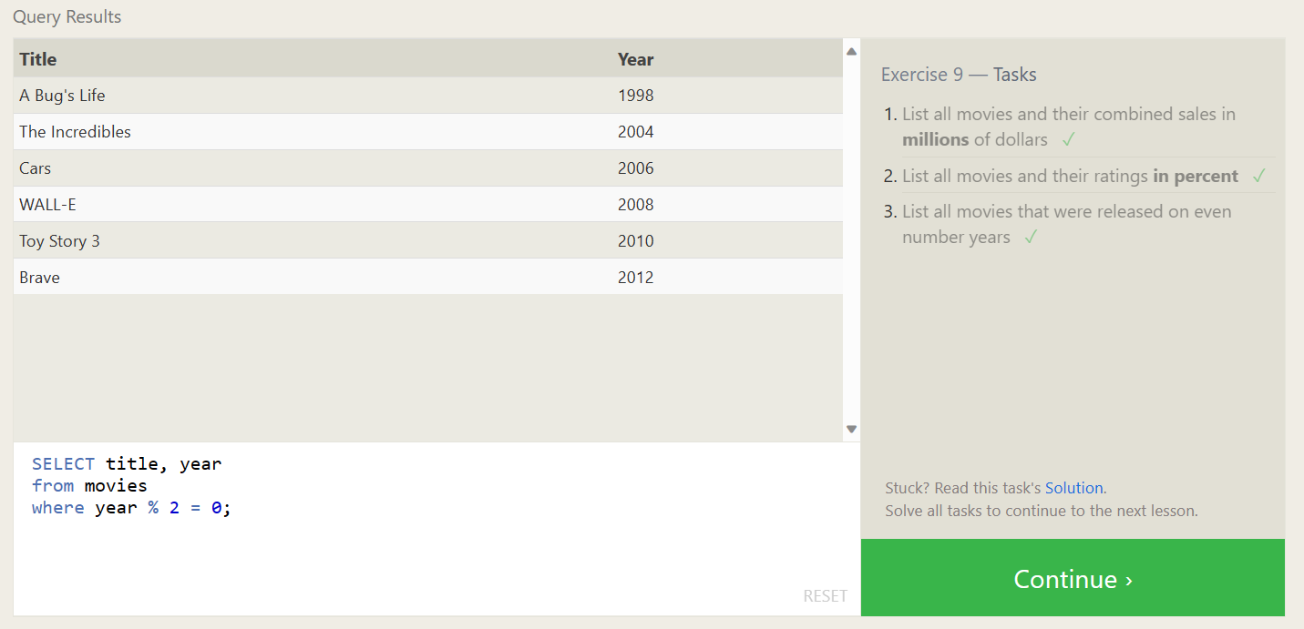

SELECT title, (domestic_sales + international_sales) / 1000000 as gross_sales_millions from movies join boxoffice on movies.id = boxoffice.movie_id;

SELECT title, rating * 10 as rating_percent FROM movies join boxoffice on movies.id = boxoffice.movie_id;

SELECT title, year FROM movies where year % 2 = 0;

**SQL Lesson 10: Queries with aggregates (Pt. 1)**

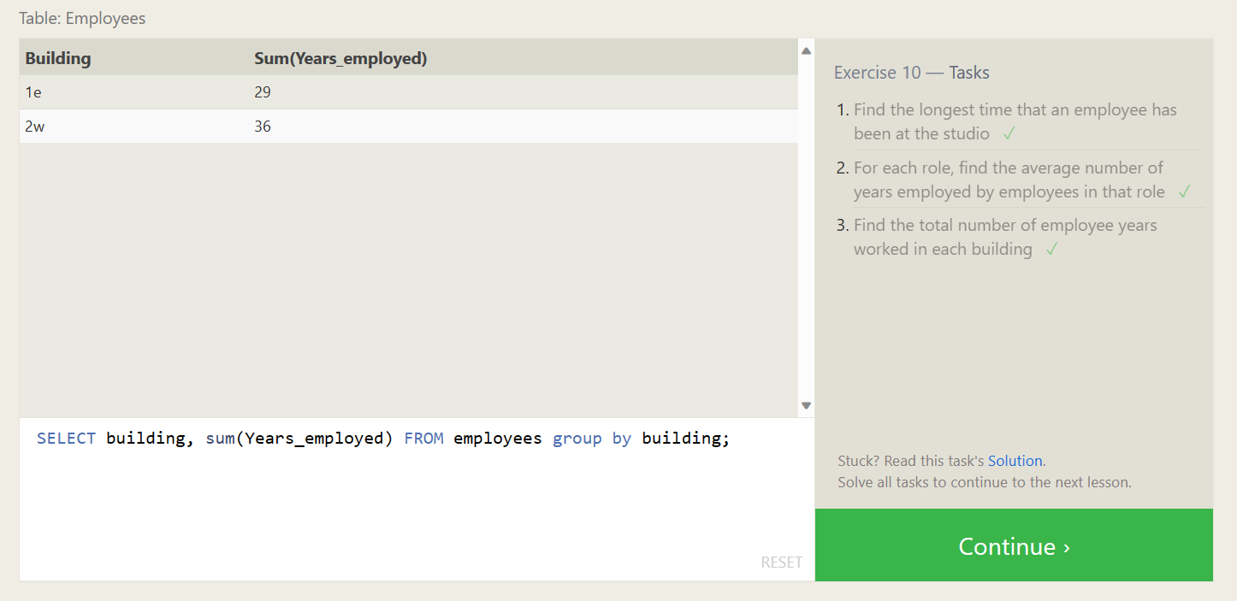

SELECT max(Years_employed) FROM employees;

SELECT role,avg(Years_employed) FROM employees group by role;

SELECT building, sum(Years_employed) FROM employees group by building;

**SQL Lesson 11: Queries with aggregates (Pt. 2)**

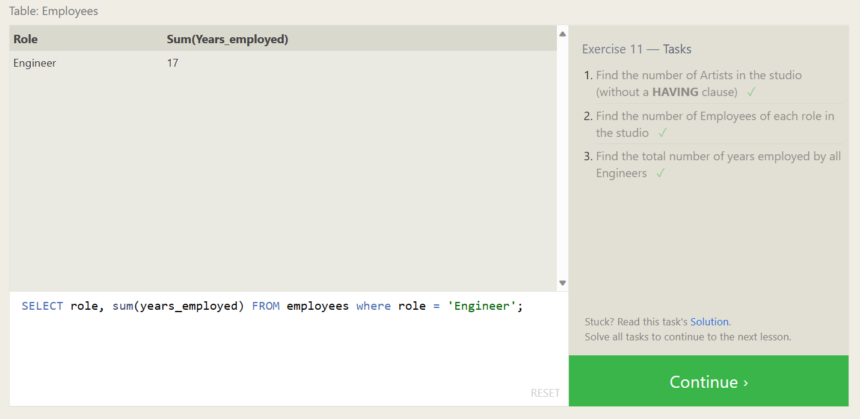

SELECT count(*) FROM employees where role = 'Artist';

SELECT role, count(*) FROM employees group by role;

SELECT role, sum(years_employed) FROM employees where role = 'Engineer';

**SQL Lesson 12: Order of execution of a Query**

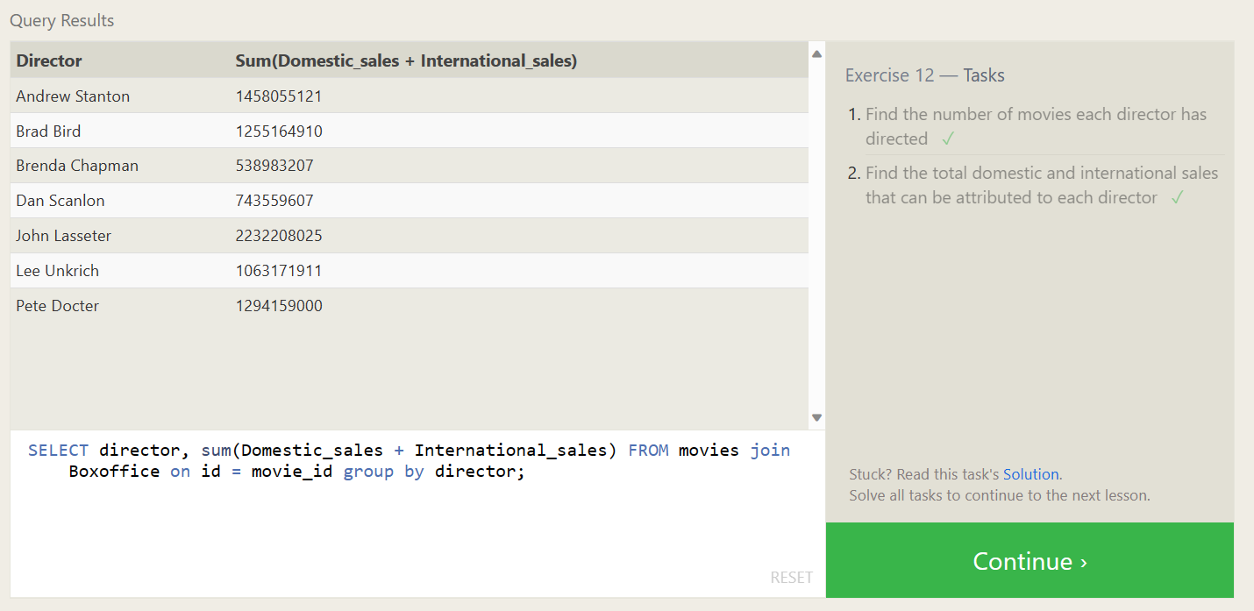

SELECT director, count(*) FROM movies group by director;

SELECT director, sum(Domestic_sales + International_sales) FROM movies join Boxoffice on id = movie_id group by director;

**SQL Lesson 13: Inserting rows**

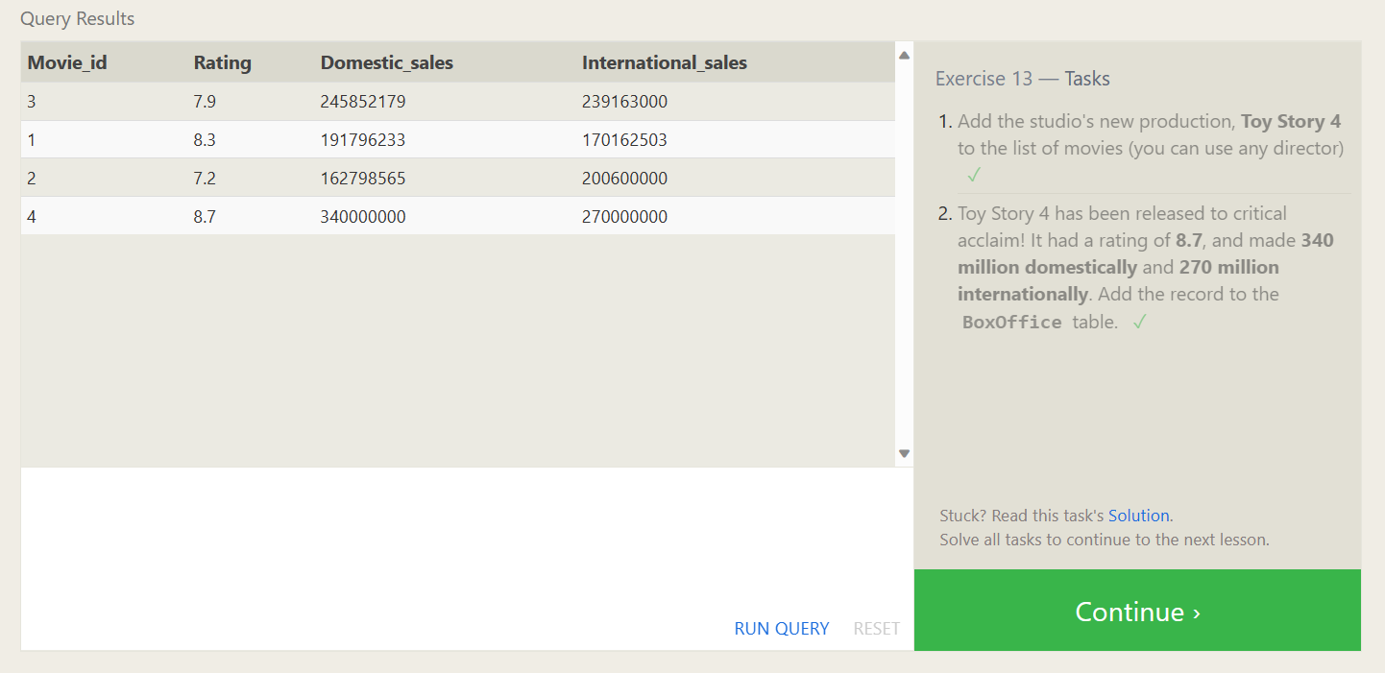

Insert into movies values (4, "Toy Story 4", "El Directore", 2015, 90);

Insert into boxoffice values (4, 8.7, 340000000, 270000000);

**SQL Lesson 14: Updating rows**

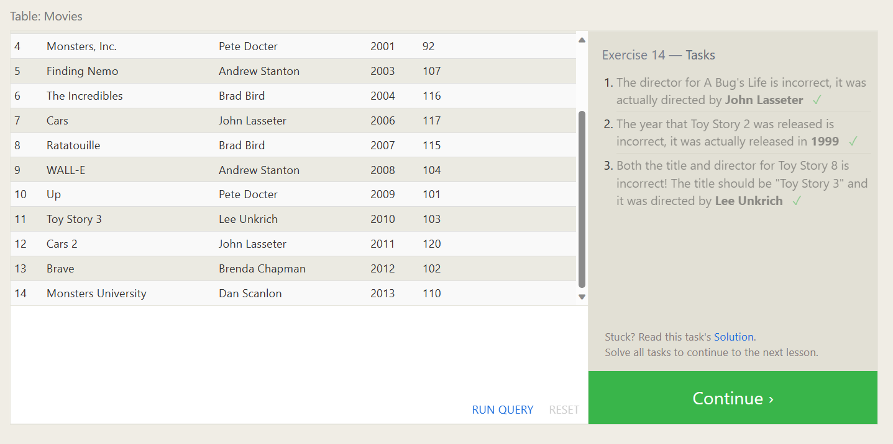

update movies set director = "John Lasseter" where id = 2;

update movies set year = 1999 where id = 3;

update movies set title = 'Toy Story 3', director = 'Lee Unkrich' where id = 11;

**SQL Lesson 15: Deleting rows**

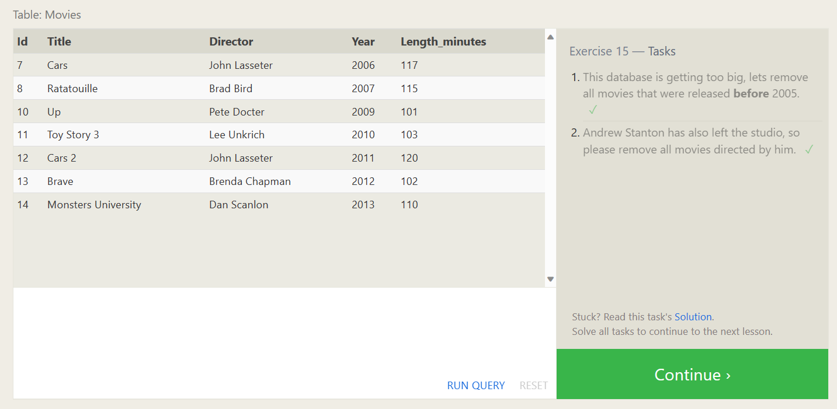

delete from movies where year <=2005;

delete from movies where director = 'Andrew Stanton';

**SQL Lesson 16: Creating tables**

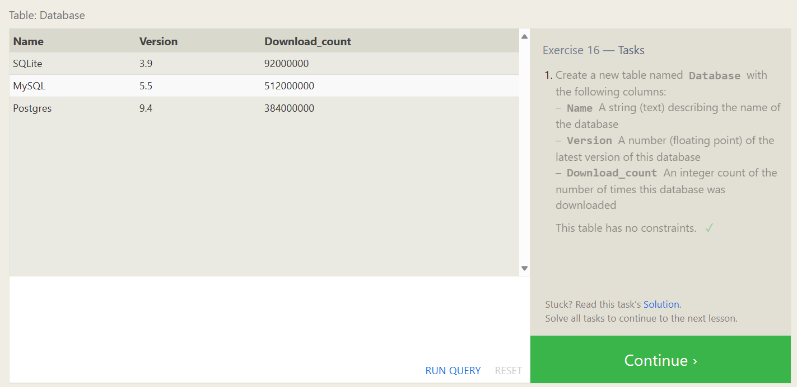

crea Database (

Name text,

Version float,

Download_count integer

);

**SQL Lesson 17: Altering tables**

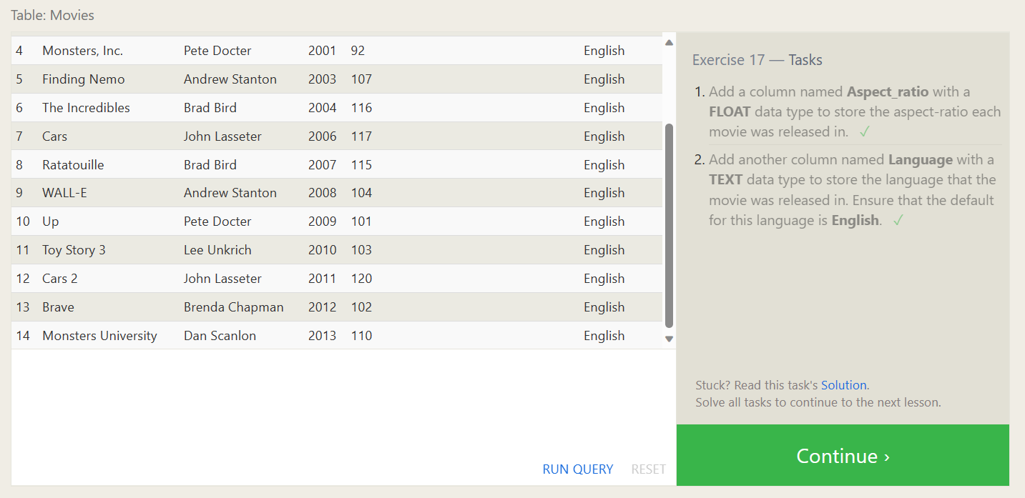

alter table movies add Aspect_ratio datatype float;

alter table movies add Language datatype text default English;

**SQL Lesson 18: Dropping tables**

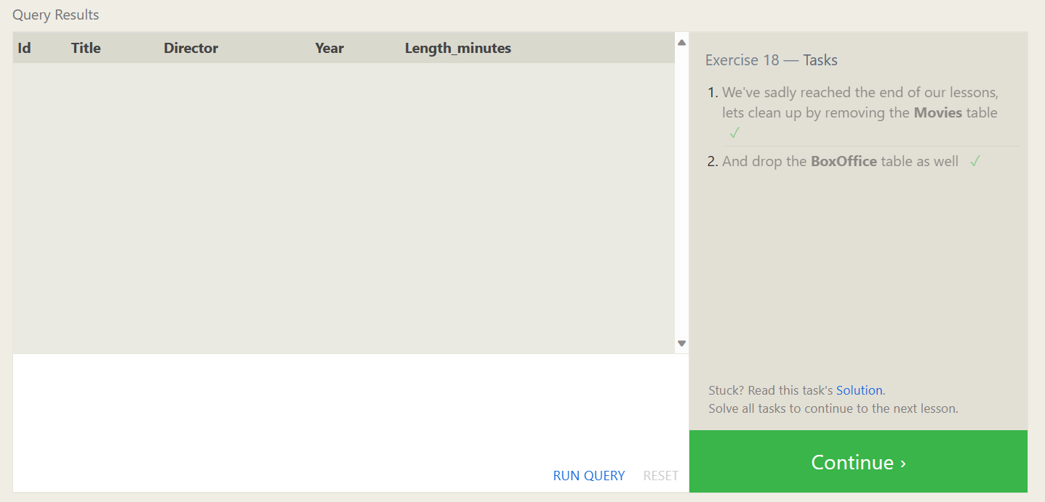

drop table if exists movies;

drop table if exists Boxoffice;